**Figure 1: Constraints of Open Space in Watchfield**

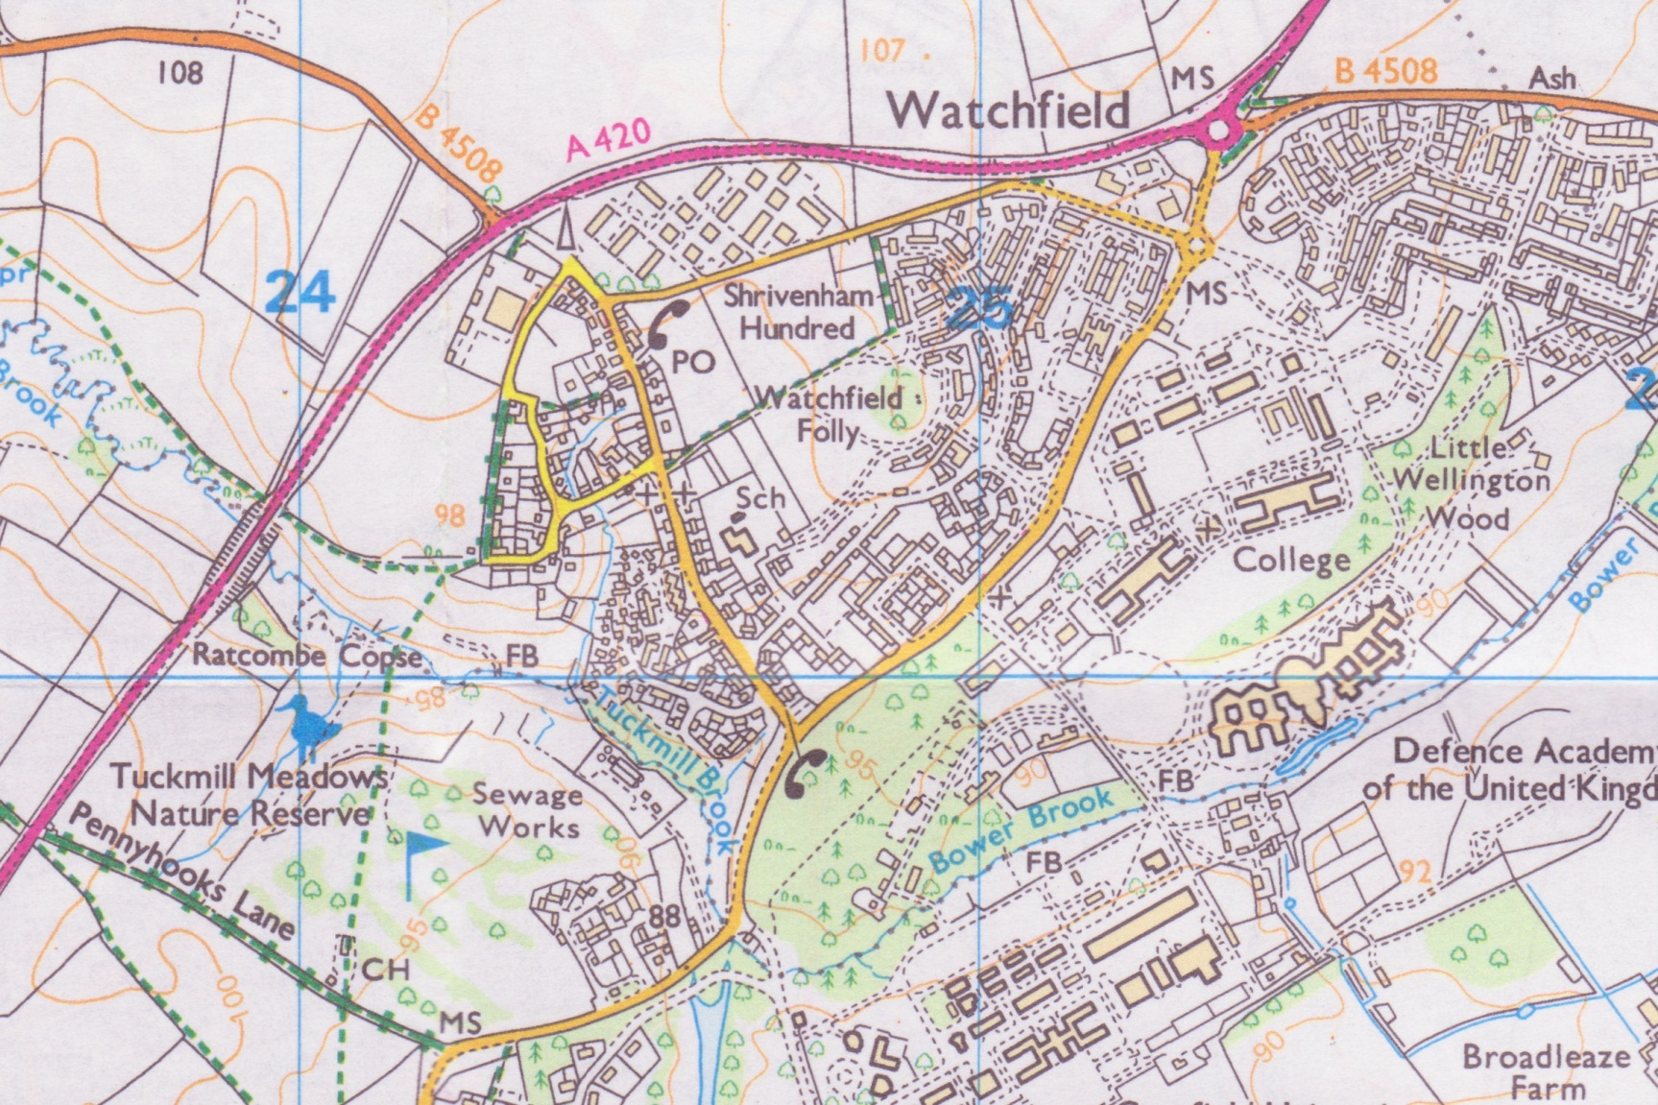

2

1

3

9

7

4

10

7

6

5

MOD HOUSING & DEFENCE ACADEMY

GOLF COURSE & NATURE RESERVE

8

|  |  |  |  |
| --- | --- | --- | --- |
| 10 | Cowan’s Camp Field | 5 | Church and Burial ground |
| 9 | 120 House Approved Development | 6 | School |
| 8 | Sewage Works and Industrial Units | 3 | Shrivenham 100 Business Park |
| 7 | Allotments and Paddocks | 2 | Anglo-Saxon Burial Ground |
| 4 | Football Pitches | 1 | Co-Op Etc |

**FIGURE 5**

**Cowan’s Camp Noise Surveys**

**Daytime Surveys 1 – 7**

**Survey 1**

**Survey 2**

**Survey 3**

**Survey 4**

**Survey 5**

**Survey 6**

**Survey 7**

**Night time Surveys 8-9**

**Survey 8**

**Survey 9**

**Figure 6: Watchfield Village Biodiversity Survey Data for Cowan’s Camp Field**

Villagers were asked to record their observations during 2012 on Cowan’s Camp field

**Mammals**

Muntjac Deer

Fallow Deer

Hedgehog

Badger

Fox

Pipistrelle Bat

Brown Long-Eared Bat

Natterer’s Bat

Mole

Grey Squirrel

Rabbit

Hare

Weasel

Brown Rat

Common Shrew

Pygmy Shrew

Field Vole

Wood Mouse

Yellow-Necked Mouse

**Birds**

Red Kite

Kestrel

Hobby

Buzzard

Sparrowhawk

Barn Owl

Tawny Owl

Swift

**Birds (Cont.)**

Swallow

House Martin

Green Woodpecker

Greater Spotted Woodpecker

Lesser Spotted Woodpecker

Skylark

Tree Pipit

Meadow Pipit

Wood Pigeon

Collared Dove

Pheasant

Grey Partridge

Fieldfare

Pied Wagtail

Grey wagtail

Waxwing

Starling

Dunnock

Wren

Willow Warbler

Ciffchaff

Goldcrest

Whitethroat

Blackcap

Spotted Flycatcher

Robin

Blackbird

Redwing

Song Thrush

Mistle Thrush

Blue Tit

Great Tit

**Birds (Cont.)**

Coal Tit

Long-Tailed Tit

Nuthatch

Treecreeper

Yellowhammer

Chaffinch

Brambling

Bullfinch

Goldfinch

Greenfinch

Linnet

House Sparrow

Jay

Magpie

Jackdaw

Carrion Crow

Rook

Lapwing

Tree Sparrow

**Retiles & Amphibians**

Common Lizard

Slow-Worm

Grass Snake

Adder

Great Crested Newt

Palmate Newt

Smooth Newt

Common Frog

Common Toad

**Invertebrates**

Large White Butterfly

Small White Butterfly

Green-Veined White Butterfly

Orange Tip Butterfly

Wood White Butterfly

Brimstone Butterfly

Hunting Spider

2-Spot Ladybird

7-Spot Ladybird

10-Spot Ladybird

Cockchafer

Buff-Tailed Bumblebee

Common Carder Bee

Meadow Bumblebee

White-Tailed Bumblebee

Red-Tailed Bumblebee

Honeybee

Wood Ant

Hoverfly

Hornet

Red Ant

Beefly

Mosquito

Hawthorn Shield Bug

Cranefly

Magpie Moth

Harvestman

Dark Bush Cricket

Comma Butterfly

Common Blue Butterfly

Ringlet Butterfly

Leopard Slug

**Invertebrates (Cont.)**

Lacewing

Earwig

Common Blue Damselfly

Red Admiral Butterfly

Meadow Brown Butterfly

Chalkhill Blue Butterfly

Five Spot Burnet Moth

Heart and Dart Moth

Centipede

Skipper Butterfly

Millipede

Woodlouse

Small Heath Butterfly

Garden Spider

Brown-Lipped Snail

Grasshopper

Green Shield Bug

Peacock Butterfly

Green Hairstreak Butterfly

Small Blue Butterfly

Cinnabar Moth

Small Tortoiseshell Butterfly

Pearl-Bordered Fritillary Butterfly

Marsh Fritillary Butterfly

Grayling Butterfly

Gatekeeper Butterfly

Meadow Brown Butterfly

Small Heath Butterfly

Small Skipper Butterfly

Large Skipper Butterfly

Dingy Skipper

Lappet Moth

**Invertebrates (Cont.)**

Eyed Hawkmoth

Poplar Hawkmoth

Puss Moth

Garden Tiger Moth

White Ermine Moth

Sallow Kitten Moth

Hebrew Character Moth

Burnished Brass Moth

Brimstone Moth

Swallowtailed Moth

Angle Shades Moth

Mother Shipton Moth

Speckled Yellow Moth

White Plume Moth

Herald Moth

Violet Groundbeetle

Great Grey Slug

Garden Slug

Large Black Slug

Garden Snail

White-Lipped Banded Snail

Earthworm

Banded Demoiselle

Common Green Grasshopper

Common Field Grasshopper

Meadow Grasshopper

Speckled Bush Cricket

Red and Black Leafhopper

Blackfly

St Mark’s Fly

Horse Fly

Wasp Beetle

**Invertebrates (Cont.)**

Birch Sawfly

Black Ant

Sexton Beetle

Devil’s Coach Horse

Wasp Beetle

Longhorn Beetle

Common Cross Spider

Spider Dysdera crocata

Swamp spider

Crab spider Misumena vatia

Daddy Long-legs

Zebra spider

Crab spider Xysticus cristatus

**Plants**

Pyramid Orchid

Common Spotted Orchid

Bee Orchid

Knotted Hedge Parsley

Ragwort

Groundsel

Creeping Thistle

Dandelion

Yarrow

Harebell

Sycamore

Field Bindweed

Squirreltail Fescue

Madder

Hedge Bindweed

Comfrey

**Plants (Cont.)**

Prickly Lettuce

Bugle

Pignut

White Dead-Nettle

Red Dead-Nettle

Common Speedwell

Toadflax

Thyme-leafed Speedwell

Red Valerian

Buddlea

Yellow Rattle

Red Fescue

Cleavers

Foxglove

Spear Thistle

Barren Brome

Soft Brome

Plantain

Field Scabious

Cock’s Foot

Daisy

Cuckoo Flower

Bramble

False Oat Grass

Bush Vetch

Cut-Leaf Cranes Bill

Red Clover

White Clover

Dog’s Mercury

Loosestrife

Field Forget-me-not

Rosebay Willowherb

**Plants (Cont.)**

Hogweed

Ground Elder

Yoprkshire Fog

Cow Parsley

Cowlsip

Biting Stonecrop

Primrose

Nipplewort

Hawthorn

Wheat

Welted Thistle

Common Bent

Field Rose

White Campion

Sheep’s Fescue

Shepherd’s Purse

Lesser Burdock

Meadowsweet

Rough Meadow Grass

Common Nettle

Blue Fleabane

Teasel

Ragged Robin

Bittersweet

Garlic Mustard

Perforate St-John’s Wort

Broad-Leaf Dock

Meadow Buttercup

Silverweed

Fat Hen

Wood Avens

Hairy Bittercress

**Plants (Cont.)**

Curled Dock

Opium Poppy

Tufted Vetch

Horse Chestnut

Wild Privet

Hazel

Dogwood

Lime

Apple

Barberry

Hornbeam

Ash

Wild Cherry

Purple Toadflax

Crab Apple

Dog Rose

Maple

Spindle

Hybrid Campion

Smooth Sow-thistle

Cherry Laurel

Sticky Mouse-ear

Blackthorn

Elder

Ground Ivy

Good King Henry

Knotgrass

Monks Rhubarb

Field Madder

Common Mouse Ear

Common Chickweed

Barley

**Plants (Cont.)**

Heath Wood-rush

Lesser Celandine

Selfheal

Common Cornsalad

Creeping Buttercup

Hedge Mustard

Downy Birch

Black Medick

Common Poppy

Common fumitory

Common Whitlowgrass

Wild Radish

Dog-Rose

Wild Strawberry

Creeping Cinquefoil

Bird’s Foot Trefoil

Broomrape

Giant Fescue

Herb Robert

Rye Grass

Autumn Hawkbit

Common Dog Violet

Sweet Violet

Dove’s-foot Crane’s-bill

Common Cleavers

Marjoram

Great Mullein

Thyme

Wild Carrot

Tansy

Black Knapweed

Cut-leaf Crane’s-bill

**Plants (Cont.)**

Common Catsear

Common Sedge

Broad-leaf Willowherb

Quaking Grass

Herb Robert

Timothy Grass

Spearmint

Lesser Trefoil

Hart’s Tongue Fern

Spotted Medick

Moss

Liverwort

Silver Birch

English Elm

Lichen

Orange Peel Fungus

Coral Spot Fungus

Many-Zoned Polypore

Hairy Stereum

Honey Fungus

Clouded Agaric

Parasol Mushroom

Shaggy Ink-Cap

Blackening Wax Cap

Creeping Thistle

Milking Mycena

Little Japanese Umbrella

Trooping Crumble Cap

Suphur Tuft

Ganoderma Applanatum

Silver Leaf Fungus

**Figure 7**

**Near miss traffic data: Extract from Watchfield Primary School Headteacher’s Report, November 2012**



