T2550 EMERGENCY CLOSURE B4508 Westmill Bridge (West of Shrivenham and the A420 – road towards Highworth)
12.00pm Wednesday 14th January 2015 – for approximately one week until Friday 23rd January 2015.

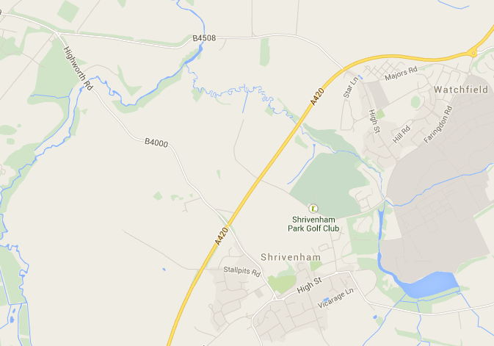
Closure at Westmill Bridge

