T2638 URGENT CLOSURE B4508 Westmill Bridge (West of Shrivenham and the A420 – road towards Highworth)
Monday 9th February 2015 for approximately 5 days

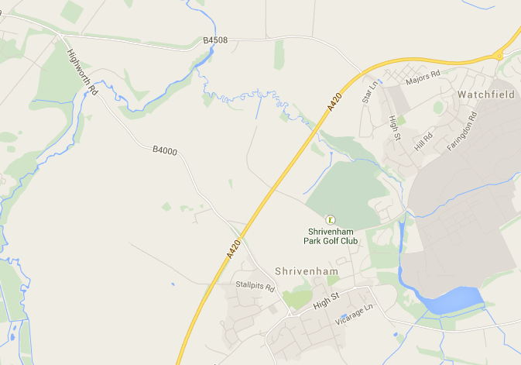
Closure at Westmill Bridge

