….accessible transport for the community

VILLAGES SHOPPERBUS
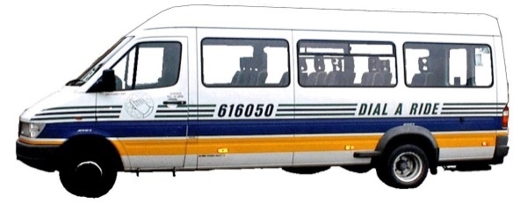

An accessible door to door service for people who do not have access to transport, operating on a flexible route. This service is supported by Oxfordshire County Council.

WHERE DOES IT GO?
From Longcot, Shrivenham, Watchfield, Bourton and Ashbury to Sainsbury’s at Stratton and Swindon Town Centre.

BOOKINGS
01793 616050

HOW MUCH DOES IT COST?
The return fare is £5.50. Oxfordshire bus passes can be used on this service.

WHEN DOES IT OPERATE?
Every Wednesday and Friday (Except Bank Holidays).

We pick up from:
Longcot
Shrivenham
Watchfield Bourton
Ashbury

Pickups start at 10.00am. The route and exact times depend on the bookings for the day

Return from Swindon Town Centre at 1:30pm.

BOOKING
Telephone Swindon 616050 after 12 noon. Journeys can be booked up to a week in advance.

Passengers need to register before using the service

Swindon Dial A Ride, Newcombe Drive, Hawksworth Trading Estate, Swindon, SN2 1DZ
Registered Industrial & Provident Society No. 24896R

August 2018
….accessible transport for the community

VILLAGES SHOPPERBUS

An accessible door to door service for people who do not have access to transport, operating on a flexible route. This service is supported by Oxfordshire County Council.

WHERE DOES IT GO?
From Longcot, Shrivenham, Watchfield, Bourton and Ashbury to Sainsbury’s at Stratton and Swindon Town Centre.

BOOKINGS
01793 616050

HOW MUCH DOES IT COST?
The return fare is £5.50. Oxfordshire bus passes can be used on this service.

WHEN DOES IT OPERATE?
Every Wednesday and Friday (Except Bank Holidays).

We pick up from:
Longcot
Shrivenham
Watchfield Bourton
Ashbury

Pickups start at 10.00am. The route and exact times depend on the bookings for the day

Return from Swindon Town Centre at 1:30pm.

BOOKING
Telephone Swindon 616050 after 12 noon. Journeys can be booked up to a week in advance.

Passengers need to register before using the service

Swindon Dial A Ride, Newcombe Drive, Hawksworth Trading Estate, Swindon, SN2 1DZ
Registered Industrial & Provident Society No. 24896R

August 2018

