Temporary Traffic Regulation Notice – S14 Road Traffic Regulation Act 1984
Temporary Road Closure at Watchfield, B4508 Majors Road
In the interests of public safety it will be necessary for Oxfordshire County Council to close the road as detailed above in order to facilitate carriageway resurfacing works.
A temporary Notice is being made to implement the temporary closure and will operate from 12 October 2020.
The anticipated completion date is 13 October 2020. The closure will operate 20:00 to 06:00 nightly.
A Temporary Traffic Regulation Notice is being made to implement the temporary closure and restriction and will operate on the days shown above.
Please note that Notices for urgent works can last up to 5 consecutive days only.
Access will be maintained for emergency service vehicles and for those frontages within the closure area, subject to the progress of the works and liaison with the works supervisor.
A copy of the drawing showing the extent of the closure and also the alternative routes for traffic is below
Further information regarding the works may be obtained by contacting Stuart Bowler OCC Skanska, Oxfordshire County Council on 0330 105 0055 or 07823353755.
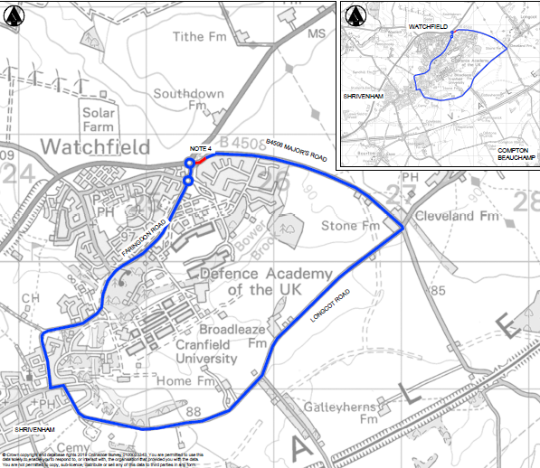
Temporary Traffic Regulation Notice – S14 Road Traffic Regulation Act 1984
Temporary Road Closure and “No Waiting” restriction at Shrivenham, Faringdon Road
In the interests of public safety, it will be necessary for Oxfordshire County Council to close the road and impose a ‘No Waiting’ restriction as detailed above to facilitate carriageway resurfacing works.
A temporary Notice is being made to implement the temporary closure and will operate from 14 October 2020 up to and including 16 October 2020. This will operate between 20:00 and 06:00
A Temporary Traffic Regulation Notice is being made to implement the temporary closure and restriction and will operate on the days shown above.
Please note that Notices for urgent works can last up to 5 consecutive days only.
Access will be maintained for emergency service vehicles and for those frontages within the closure area, subject to the progress of the works and liaison with the works supervisor.
A copy of the drawing showing the extent of the closure and restriction and also the alternative route for traffic is below
Further information regarding the works may be obtained by contacting Elizabeth Smith / Stuart Bowler, Oxfordshire County Council on 0345 310 11 11.

