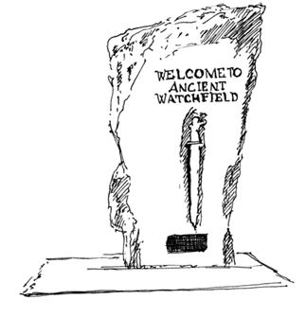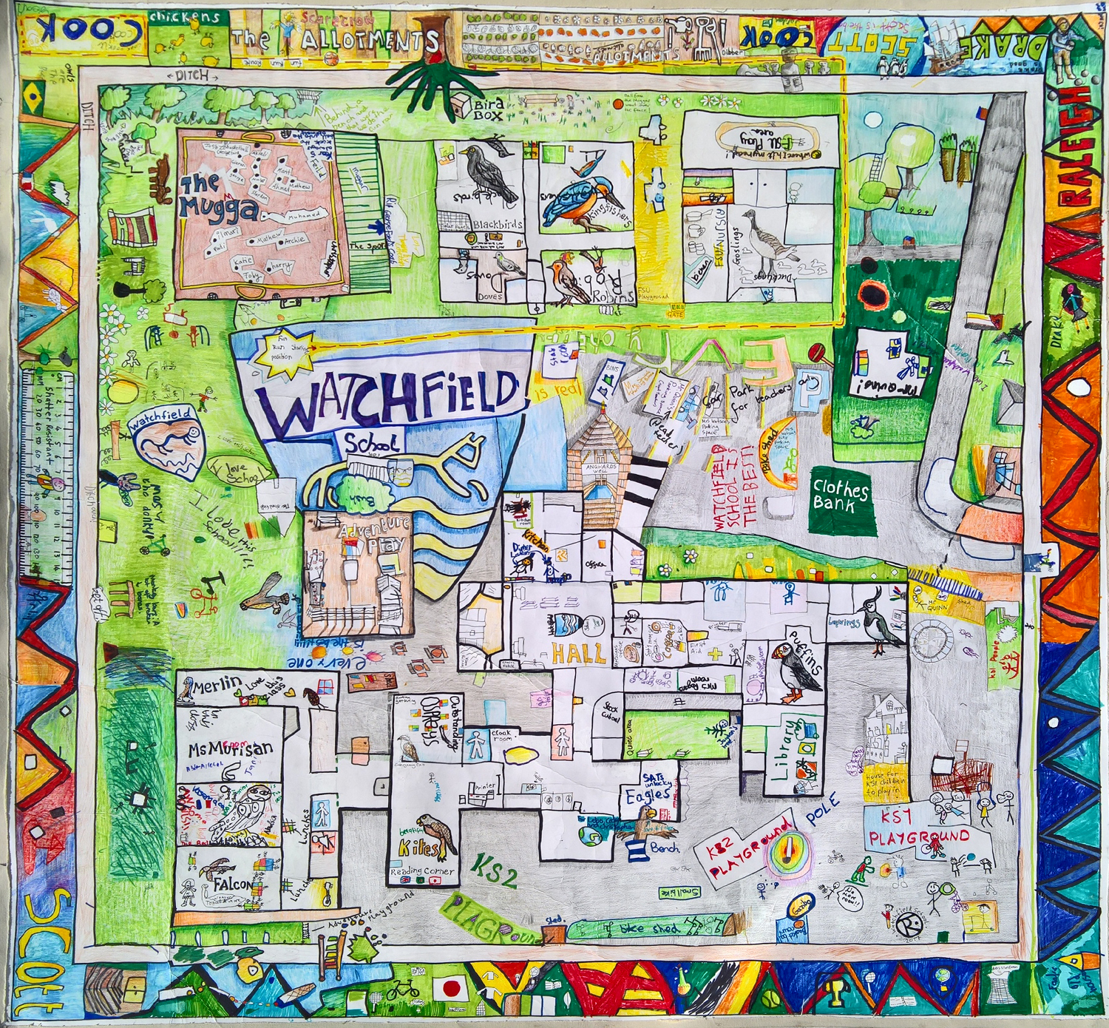
WATCHFIELD ANNUAL VILLAGE
VIRTUAL ASSEMBLY

TUESDAY MAY 4TH
7.30pm

Join Zoom Meeting
https://us02web.zoom.us/j/81949785660?pwd=aityNEgra2JUQTBBWDR6cW1neGRLQT09

Meeting ID: 819 4978 5660
Passcode: 540616
All Watchfield Residents are Welcome to Attend.

Invited Speakers to include;
Watchfield Parish Council
County Council
District Council
Police
Watchfield School
Defence Academy
Local Groups

