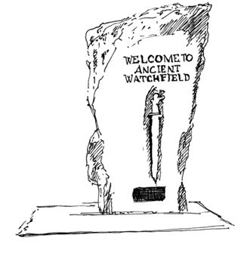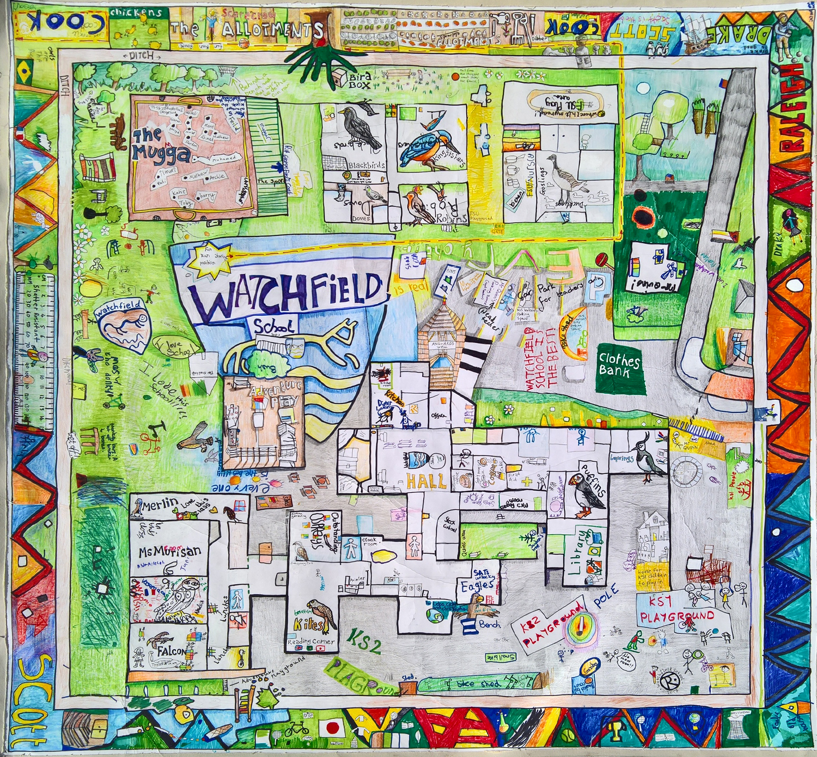
WATCHFIELD ANNUAL VILLAGE ASSEMBLY

TUESDAY MAY 14th 2024
7.00pm

WATCHFIELD VILLAGE HALL

All Watchfield Residents are Welcome to Attend.

Invited Speakers to include;
Watchfield Parish Council
County Council
District Council
Police
Watchfield School
Defence Academy
Local Groups

